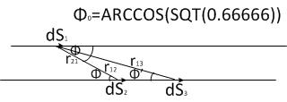
IF Ii≠0, THEN FOR F TO CHANGE SIGN, TO BECOME FROM ATTRACTIVE TO REPULSIVE,
IT SHOULD BE FIRST F=O, IT SHOULD BE 2 -3COS²Φ=0, 2/3=COS²Φ, 0.666666=COS²Φ, Φ₀=ARC₀COSSQRT(0.6666666)
THE TWO CURRENT ELEMENTS ds1, ds2 ATTRACT TO EACH OTHER, AS LONG Φ IS SMALLER THAN Φ0. r12 AND r21 BECOME SMALLER. Φ’ FOR A RANDOM CURRENT ELEMENT, AS SHOWN, BECOMES SMALLER AND SMALLER AND EVENTUALLY, SMALLER THAN Φ0.
THEN THE FORCE BETWEEN THE INTERACTING ELEMENTS REVERSES AND BECOMES STRONGLY REPULSIVE. THEN THE CURRENT BREAKS IN TWO PARTS. ONE CONNECTED BACK TO THE SOURCE AND THE SECOND IS A SEPARATE CURRENT, A PULSE.
THE ARRIVAL VELOCITY u, WITH ENERGY E₀=1/2mu², FOR CHARGES FROM A POTENTIAL V₁ TO V2, V2-V₁= V, IS: u=√(2V/m)=(2V/m)^{1/2}, OBVIOUSLY, THE ACTUAL ARRIVAL ENERGY E AND VELOCITY v WILL BE BIGGER THAN E₀ AND u RESPECTIVELY E>E₀, v>u=(2V/m)1/2, DUE TO THE ASSISTING ACCELERATION OF THE CHARGES,
ARRIVING AT THE ANODE WITH POTENTIAL V₂ FROM A POTENTIAL V_{1,} WITH V=V₂-V₁.
SUPER FAST ELECTRONS MAY REACH THE ANODE, IN RADIO TRANSMITTERS TUBES, AND TURN IT RED HOT RED, AS THE AUTHOR HAD EXPERIENCED IN HIS YOUTH, PLAYING WITH SELF MADE RADIO TRANSMITTERS.
THE SAME OCCURS IN THIS CASE, WITH THE ACCELERATED ELECTRONS TOWARDS THE ANODE, GAINING EXTRA CREATED ENERGY.
THIS EFFECT IMMEDIATELY CEASES AND THE RED HOT ANODE TURNS TO NORMAL TEMPERATURE, IF ONE PLACES A COIL, PREVENTING THE ELECTRON PASSAGE AND PUTTING A RESISTOR IN PARALLEL TO IT, TO PREVENT FARTHER, THIS COIL TO OSCILLATE TO ITS OWN RESONANT FREQUENCY. NO ACTUAL REASONING IS GIVEN IN THE LITERATURE, FOR THIS EFFECT OF PAPPAS-AMPERE FORCES.

CONTINUES FARTHER DOWN….
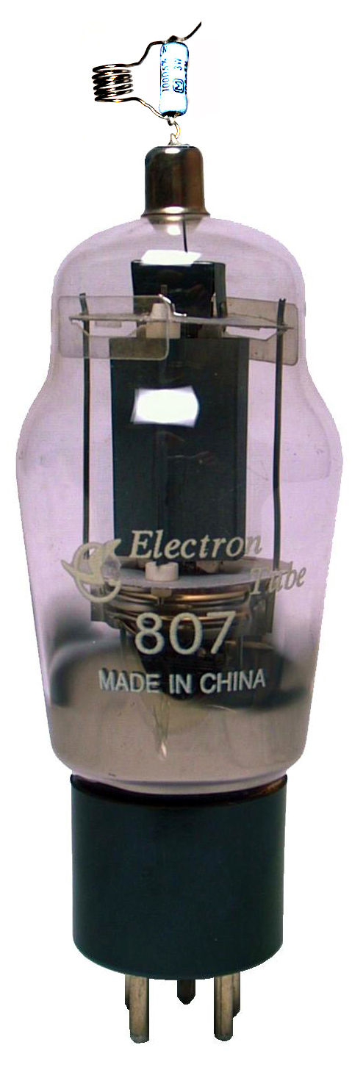
HOWEVER, THE TECHNOLOGY RECOMMENDS THIS REMEDY, WITHOUT KNOWING THE REAL REASON.

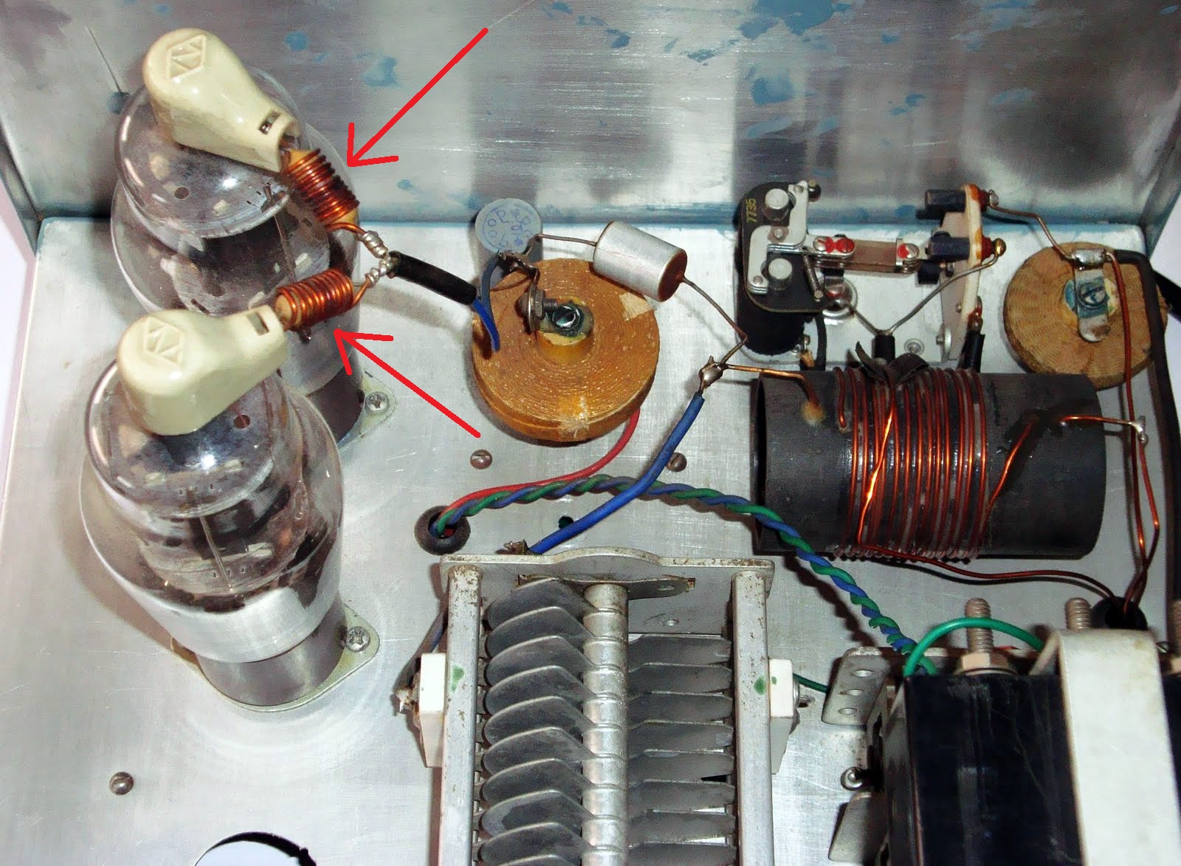
A TRANSMITTER IS EQUIPPED WITH SUCH PREVENTERS. CONTINUES FARTHER DOWN……….

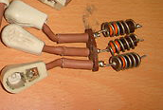
THE MARKET SELLS ALREADY TUBE CAPS, READILY EQUIPPED WITH THESE PRACTICAL PREVENTERS, WITHOUT THE SELLER KNOWS HOW THEY WORK
AND WHAT ACTUAL BAD THEY DO.
END.

